SUMMARY SLIDES FROM YESTERDAYS HUDDLE
Matching Leadership Styles with Discipleship Progress in the Huddle
We must always be conscious that even within a huddle people will be in different stages of the journey. It is necessary to consider the leadership style adopted in relation to the individual as well as the group.
L2 Leadership Style
Used with
D2 Discipleship Progress

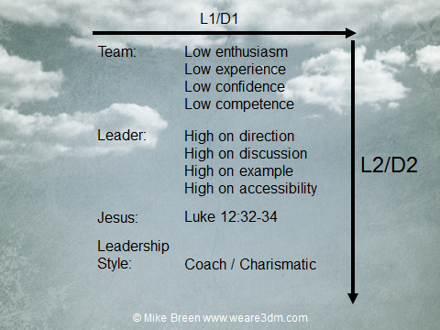
L4 Leadership Style
Used with
D4 Discipleship Progress

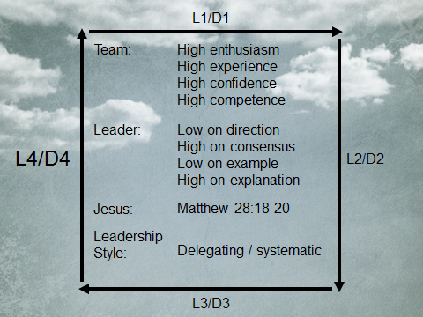
L1 Leadership Style
Used with
D1 Discipleship Progress

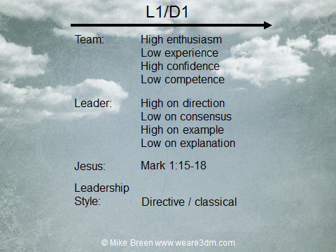
L3 Leadership Style
Used with
D3 Discipleship Progress

