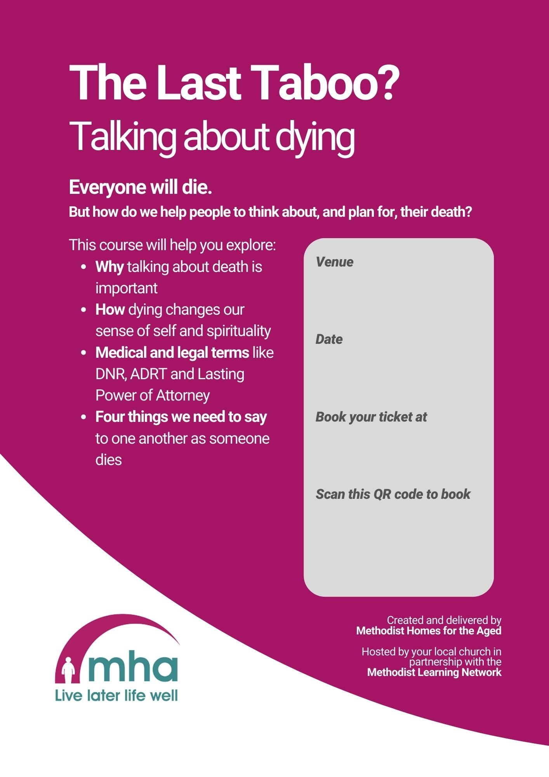
Download a custom QR code from our server. Delete this text box and paste the QR Code here.
Paste your Eventbrite link here
Type your date in here

Type your venue in here

