Sunday
17th
August

3.30pm to 5.30pm followed by Songs of Praise at 6.00pm
Price of Tea is £5.00
There will also be a bring and buy stall
Any funds raised will be given to Gambian families especially for University Education.

Please ring or email Eddie Vincent if you decide to join us.
Richard and Eddie Vincent, Parsonage Oast,
East Sutton Hill, East Sutton, Maidstone ME17 3DG
Tel 01622843299, email: eddievincent21@googlemail.com

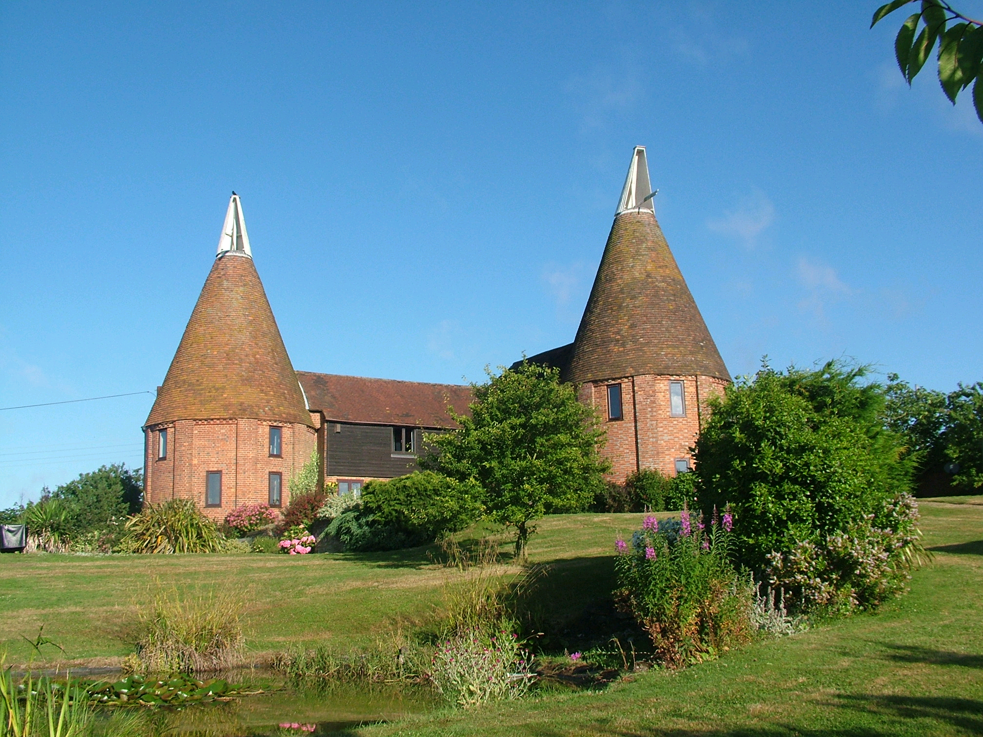
CREAM TEA
PARSONAGE OAST
EAST SUTTON

