3DM: Discipleship and Mission

By way of background, Breen is an Anglican Priest. He tells us that he was mostly trained for Temple duty, not disciple-making. Then he makes a startling point for those trained in our seminaries. “For most pastors, the operating system is not discipleship, but the church. The problem: the church is not the operating system of Jesus. Discipleship is the operating system of Jesus." He goes on to say, “The church is the effect of discipleship, not the cause of it." He claims that the operating system of discipleship is unstoppable. Profound words that shake the very foundation of seminary training.

He went on to give a historical view from the Reformation up to modern times. He is a great fan of Luther, who first translated the Bible into everyday German, making it accessible for the first time to the masses. Mike said, The Reformation put the Bible into the hands of the people. Then came the Enlightenment, and the Bible was subjected to the scrutiny of the scientific method. It was taken out of the hands of the people, and handed to the academics and professors in seminary who trained our pastors out of their doubt. The Pastors pass this gift along. Today our Biblical literacy is similar to that of the post-Reformation era.

Up, In and Out
If you’re not familiar, 3DM advocates a simple church model that uses a number of shapes to help people learn the rhythm of discipleship. The triangle is one shape they use a lot. The triangle illustrates three dimensions of our church life together: the Up, the In, and the Out. They advocate a low control/high accountability model requiring significant trust.
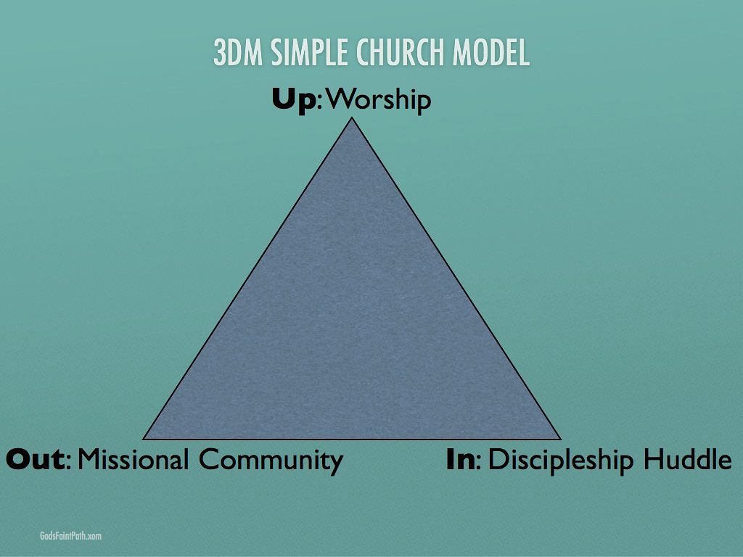
We can best worship God (Up) as a gathered assembly, raising our voices together in song, prayer and praise, while hearing the Gospel proclaimed. For many pastors, the focus on weekly worship as the centre of church life comes at the expense of discipleship and mission.
The bottom right of the triangle is the In, symbolizing our efforts to go deeper in our personal relationship with God. The In is lived out in small discipleship huddles, where you can know and be known deeply. These groups provide accountability. No one leads a huddle or a missional community without being disciples in a huddle themselves. This structure allows for the low control model to flourish. Huddles are the place of deepest transparency and vulnerability, where you experience discipleship life-on-life. Here each of us is invited into a loving relationship, and challenged to share what God is saying to us, and being held accountable to do something about it.

I never experienced this level of openness in any of the small groups I’ve joined, even gender specific groups, where it is easier to open up. Until I arrived at City Church, and joined a Spiritual Formation Group, I did not know such vulnerability. As I heard recently in a coaching session for counsellors, transparency means being open. Vulnerability means putting bullets on the table. This environment of trust and honesty is where real discipleship happens.

The third corner is the Out, our mission in the world. Huddles are limited to no more than eight people to allow trust and vulnerability, a safe place for everyone. In the 3DM model Missional Communities are formed out of missional passions that emerge in the leaders during the early huddle with the Pastor. These communities are 20 to 50 people who organize as an extended family on a mission, the Greek term Mike uses is ‘Oikos’.

Missional Communities share a passion for a place or a people, and serve the deep needs they encounter. This authentic Christian service draws others who desire to give back. They also share meals and fellowship together. Relationships form in Missional Community that help draw people closer to a true discipleship community. Most people will have their first contact with the church not through visiting a worship service, but by encountering this extended family on a mission, and wanting to help out.

Strengths, Weaknesses, Opportunities, Threats (SWOT Analysis)
Mike described the Learning Communities they are launching across the country. The two year process of peer learning with colleagues moves churches from What Is, to What Could Be, to What Will Be. He challenged the group to analyze their church along four dimensions: strengths, weaknesses, opportunities, threats. This exercise fleshes out What Is, the current reality today in the church. I first encountered this kind of SWOT analysis in doing visioning work in our company two decades ago. The SWOT exercise is great at surfacing the current reality and opportunities before the church.
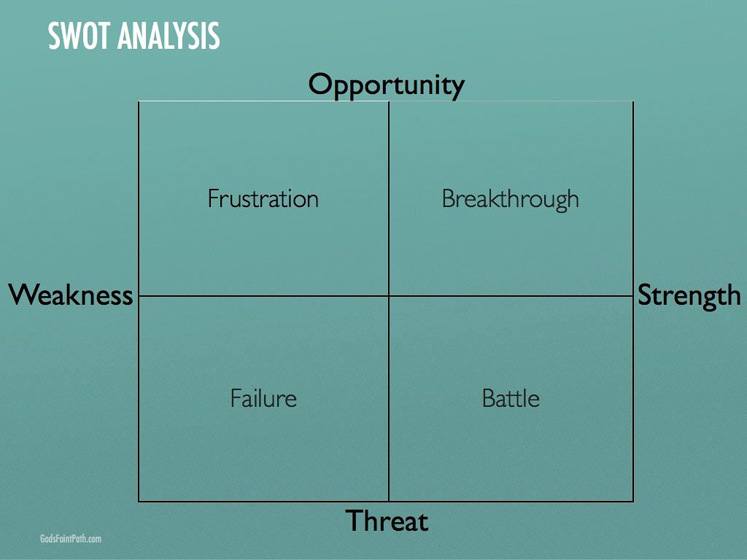
Mike brought an interesting twist to the SWOT analysis. He named the experience of each quadrant. Where Weakness encounters Opportunity, frustration is to be expected. I know that quadrant well. When you can see pathways to the future, but there is not the strength or will to pursue them, frustration is the outcome. Where Weakness encounters Threat, failure ensues. Those unprepared for battle will often capitulate at the brink of a fight. On the other hand, where Strength encounters Threat, battles will come. Think of change efforts at your church. Even if there is the Strength to pursue a new vision, those benefiting from the status quo will see a Threat, and will pitch a battle to keep you from succeeding.

However, when Strength encounters Opportunity, something beautiful is afoot. Isn’t this the quadrant where we would all like to live? Vision lies in our articulation of the opportunity we can see over the horizon. An accurate picture of where your church is on the Strength-Weakness continuum will greatly affect the outcome of attempts to reach the vision.
In breakout sessions, we completed the SWOT analysis and several people shared their analysis with the room. As people articulated their yearning for the opportunities they could see, the 3DM team asked two simple questions depicted in the next image: What will you stop doing? And, what will you start doing? This exercise demonstrates the need for pruning what is so that we can unleash healthy growth. Prune the branches to get more fruit.
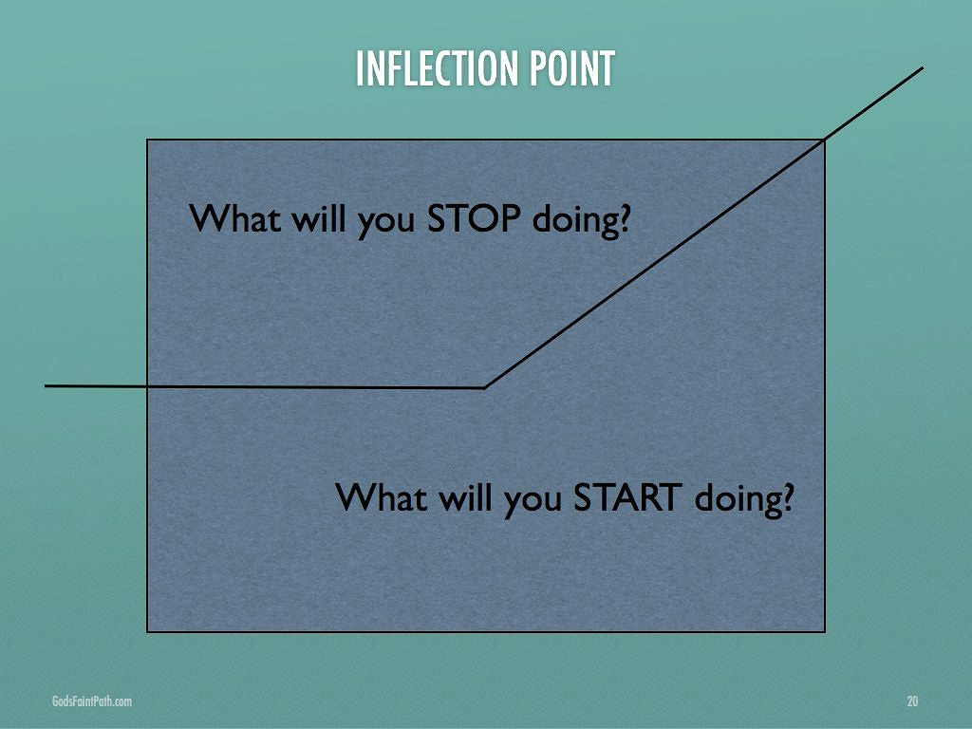
This is where the rubber meets the road. Jesus spent 80% of his time with the three and the twelve. Most pastors I’ve met do not live that kind of rhythm. To create time to disciple eight leaders in a huddle, pouring your life into them so they might disciple others, takes a significant investment of time. What will you prune to create the bandwidth for discipleship in your life?

Discipleship requires Invitation and Challenge
Mike introduced two primary dimensions of discipleship as he fleshed out his mode. The two dimensions are Invitation and Challenge. He showed how Jesus taught the Disciples through a constant process of invitation and challenge, illustrated here.
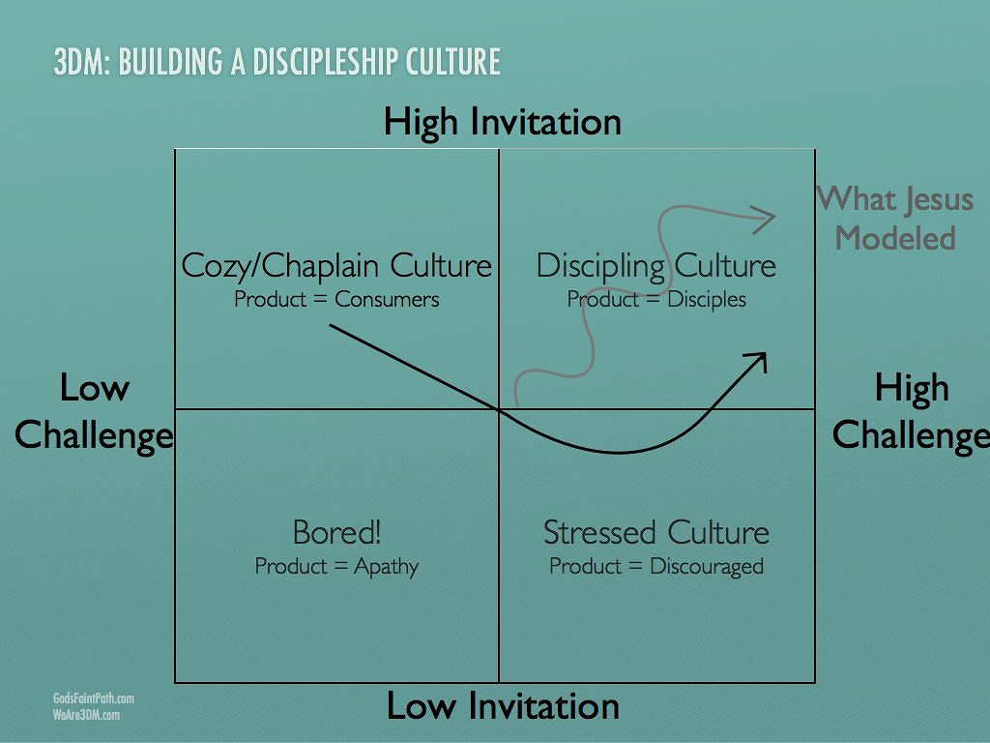
“Your church resides in one of these four quadrants today,” he said. Where there is High Invitation and Low Challenge, you will have a Cosy/Chaplain Culture. The product of that culture will be consumers. Where Low Challenge intersects with Low Invitation you will have a Bored Culture, whose product is apathy. I’ve seen many declining churches in this quadrant. There is hardly a spiritual heartbeat left, but the remnant still remains.
Where there is High Challenge and Low Invitation, you will find a Stressed Culture. The product of that culture is Discouragement. Burnout is the norm in this quadrant. But, where High Challenge intersects with High Invitation, a Discipling Culture emerges. Disciples are the product. And, where discipling is done well, the product will be disciples who can go and make disciples.
The black arrow is the pathway from Cosy/Chaplain to Discipling Culture. You cannot move directly from Cosy to Discipling. You cannot get from there to here without going through the valley of the shadow of death. In the valley, you will get the comfort of the invitation and challenge of God. The gray arrow is Jesus' model of invitation and challenge. As the pastor begins to shift time and focus to discipling leaders in huddles, the rest of the congregation will feel his/her withdrawal from the things you prune away. That results in a shift downward towards Low Invitation. So, as you move to bring challenge where there was none before, you will find yourself in the bottom right quadrant before the breakthrough.
These are the times that try men’s (and women’s) souls. Some will turn away. Some will leave. But, those who remain will increase their commitment. It is easy to turn back from the hard path at this point. Breen says, “Discipleship is meant to be simple, but hard. We have made it complicated, but simple.” This will be gut check time. Persistence and perseverance will be required. Continuing on the path will bring breakthrough, and the opportunity for real and healthy change.

Out of this quadrant will come churches that follow the advice I heard Neil Cole give at Exponential New Church Planting Conference a couple of years ago. As he said it, "First you multiply disciples, then you multiply leaders, then you can multiply churches." We've all seen subtraction and division in churches, some of us have seen addition. Wouldn't it be a blessing to see and experience multiplication?

